**Spring Data JPA with Hibernate Part 1**

**(1) Create an Employee Entity which contains following fields**

**Name**

**Id**

**Age**

**Location**

Employee Entity:

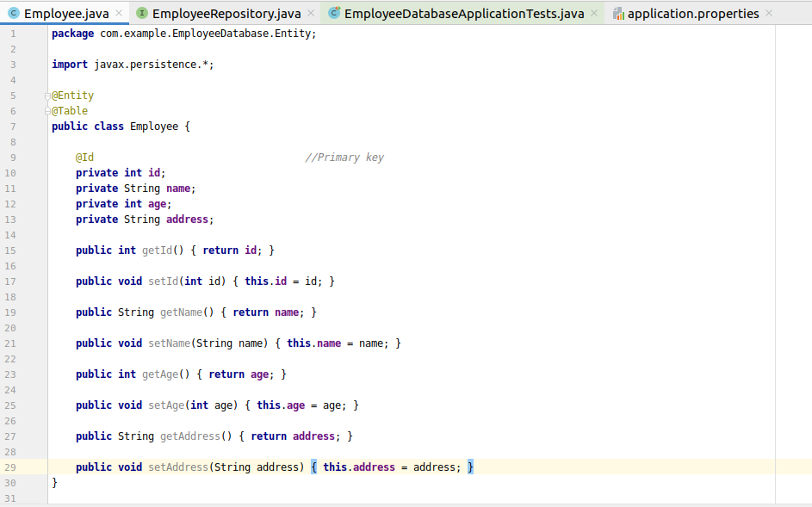

Database setup: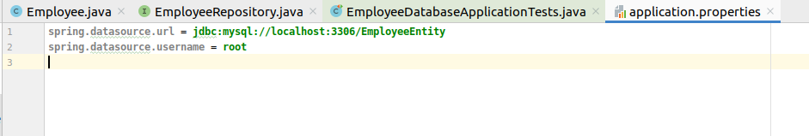

Database structure: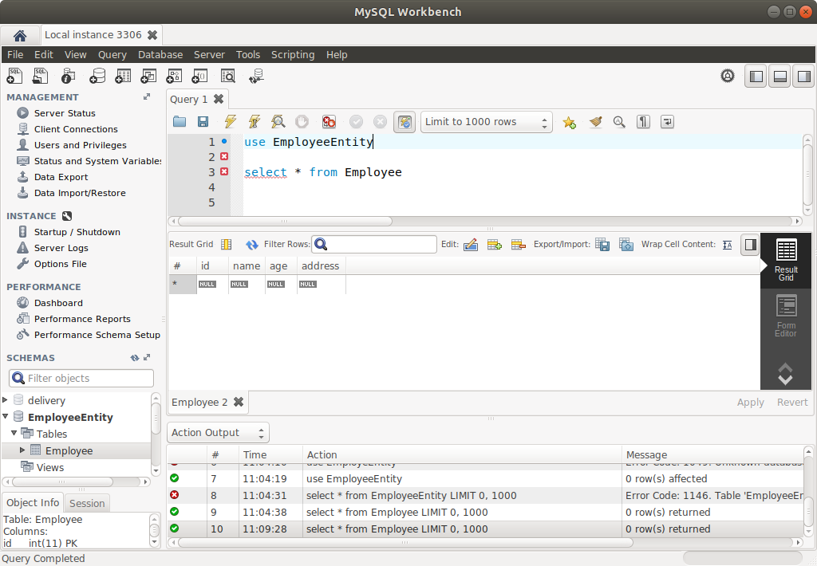

**(2) Set up EmployeeRepository with Spring Data JPA**

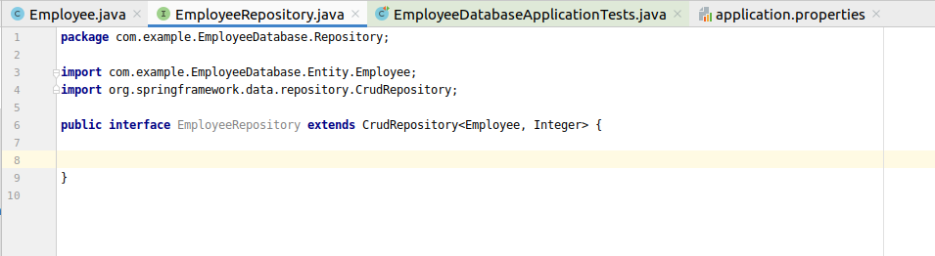

**(3) Perform Create Operation on Entity using Spring Data JPA**

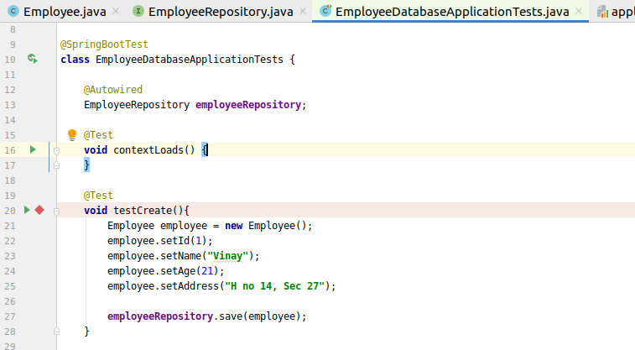

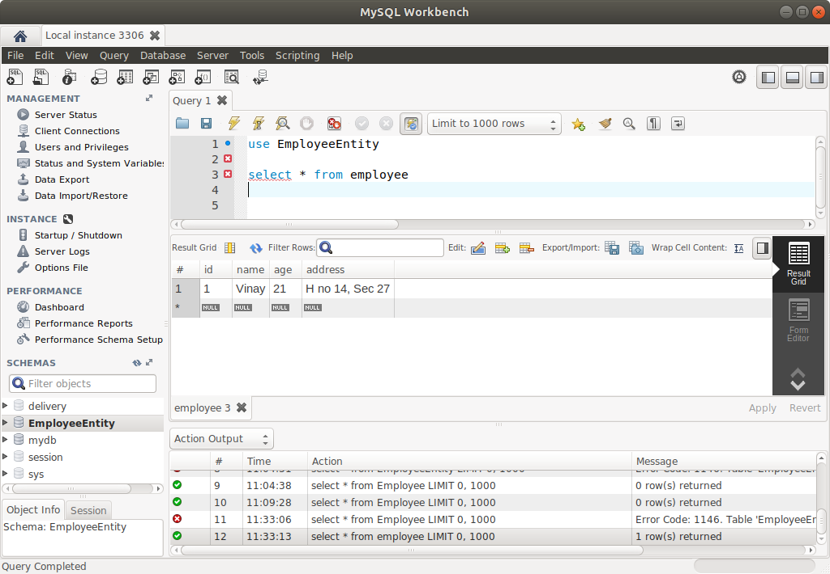

**(4) Perform Update Operation on Entity using Spring Data JPA**

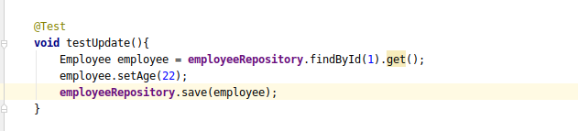

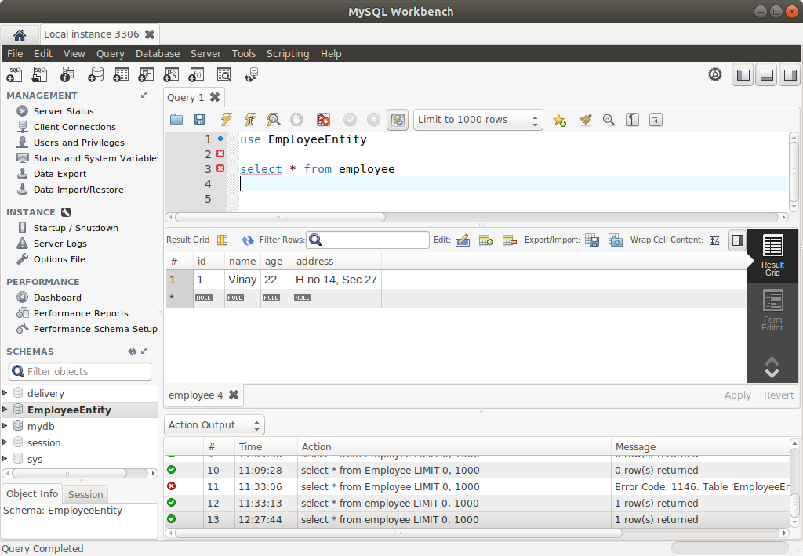

**(5) Perform Delete Operation on Entity using Spring Data JPA**

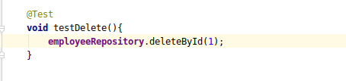

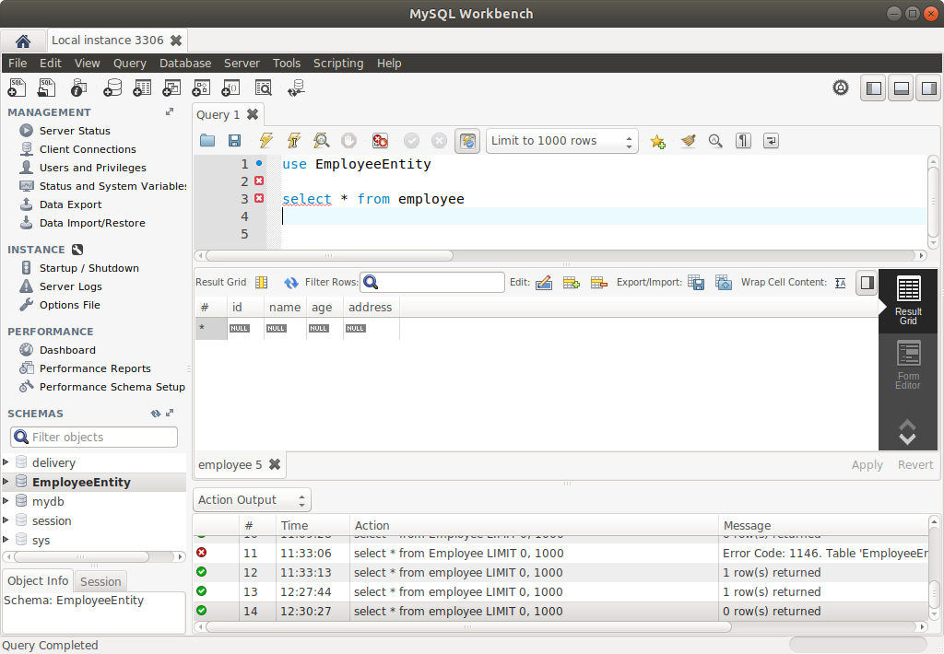

**(6) Perform Read Operation on Entity using Spring Data JPA**

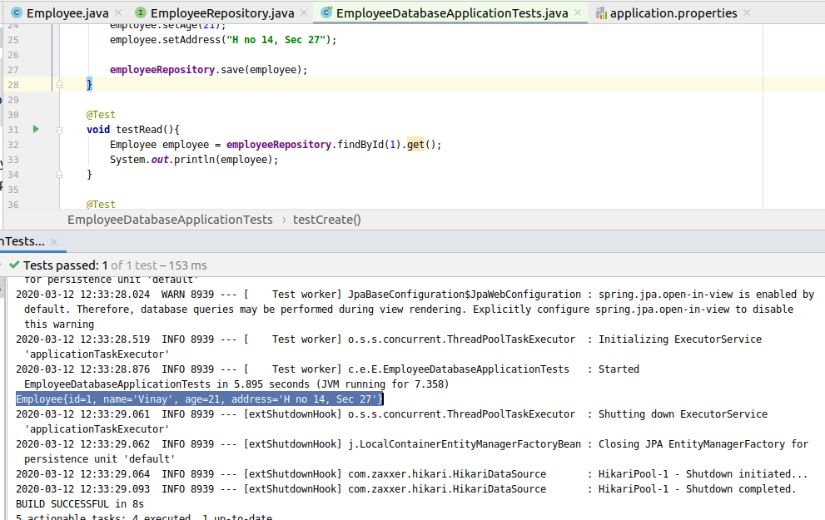

**(7) Get the total count of the number of Employees**

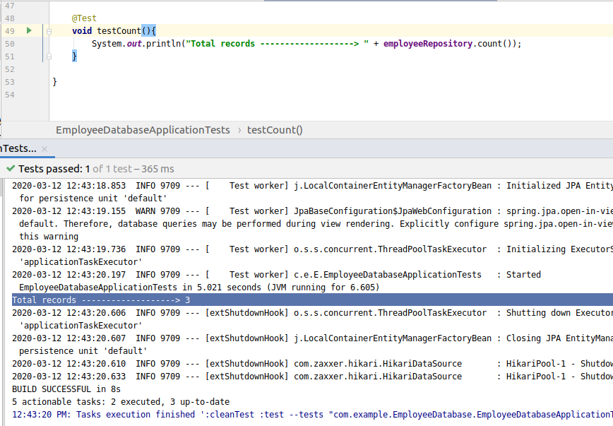

**(8) Implement Pagination and Sorting on the bases of Employee Age**

Implementing the *PageinAndSortingRepository*

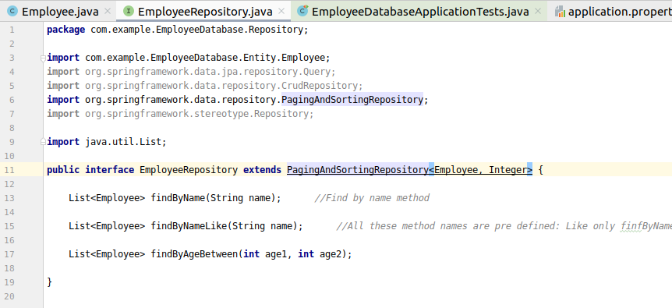

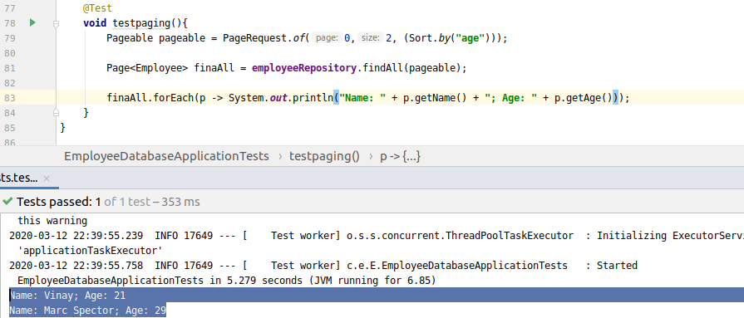

**(9) Create and use finder to find Employee by Name**

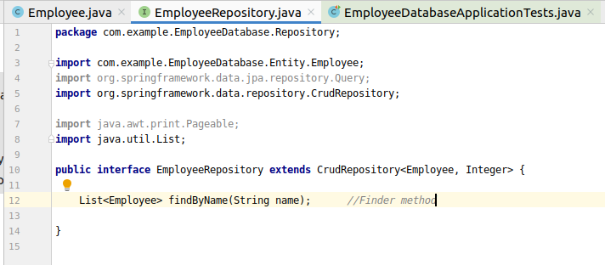



**(10) Create and use finder to find Employees starting with A character**

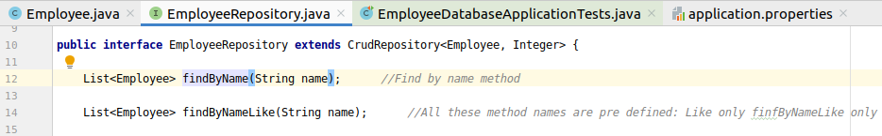

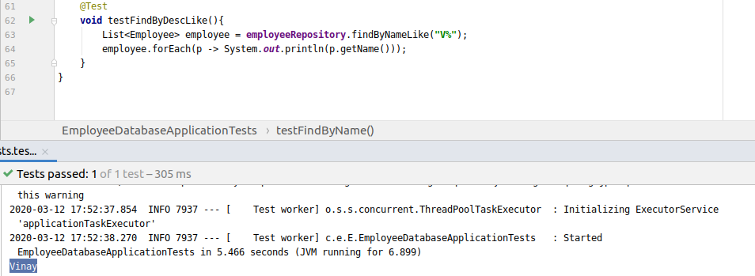

**(11) Create and use finder to find Employees Between the age of 28 to 32**

